Table of Contents

P1 Analyzing the evolution and fundamental concepts of Cloud Computing. 1

1.1 definition of cloud computing 1

1.2 advantage of cloud computing 1

1.3 evolution of cloud computing 2

1.4 popularity 2

P2. Design an appropriate architectural Cloud Computing framework for a given scenario. 5

1.about chosen architectural cloud computing framework 5

2. explanation for chosen architecture 7

P3 Define an appropriate deployment model for a given scenario. 7

1. type of development models in cloud computing 7

1.1 public cloud 7

1.2 private cloud 8

1.3 Community Cloud 9

1.4 Hybrid Cloud 9

2 explanation for chosen models 10

P4 Compare the service models for choosing an adequate model for a given scenario. 11

1. all models 11

2. explanation for chosen model 13

P1 Analyzing the evolution and fundamental concepts of Cloud Computing.

1.1 definition of cloud computing

To put it simply, Cloud Computing is the work of providing electronic services entirely over the Internet. Or rather, the provision of all resources in accordance with user requests completed over the Internet. Services here may include servers, storage, software…

Now you can store your documents somewhere "in the cloud" with some reputable solution like Google Drive or OneDrive. And as long as you have an Internet connection, you can access those data anywhere and anytime.

1.2 advantage of cloud computing

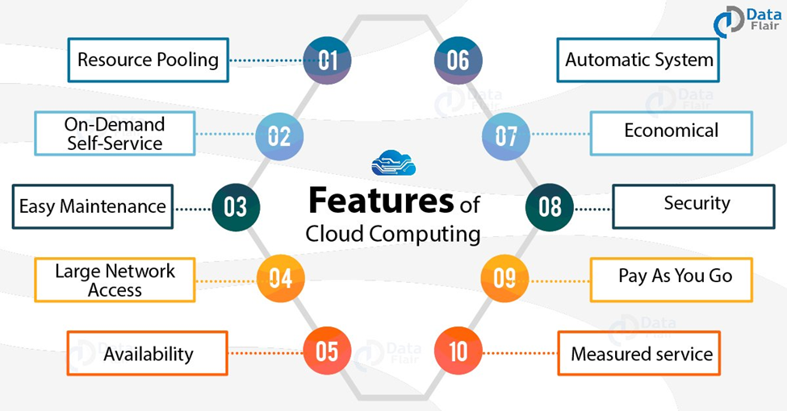

Figure 1: feature of cloud computing

Cost: Saving costs is the first benefit that Cloud Computing brings to users. Instead of having to invest in a whole server system to store data, incur annual operating or maintenance costs, you only need to spend a small amount of money to maintain them. You will be more focused on your work instead of worrying about things like maintenance or system operation.

Extensibility :The second benefit of cloud computing is its scalability. This means that you will be allocated the right amount of resources for your needs. You can add resources whenever the need arises and at the exact geographical location you desire.

Performance: The third benefit is performance. The largest cloud computing services run on a worldwide network of secure data centers. And of course they are upgraded regularly to increase efficiency and security level. Compared to a small-scale data center model like a company, this offers more positive benefits such as reduced network latency and increased economies of scale.

Security: The fourth benefit is security. Many cloud service providers offer a range of policies, technologies, and controls to strengthen your security. Thereby it helps protect your data, applications, and infrastructure from potential threats or frequent cyberattacks.

Speed: The fifth benefit is speed. Most Cloud Computing services today are offered on-demand. That means you need as much as you can get. Even large amounts of computing resources can be provisioned in just a few minutes. So you will not need to put too much pressure in planning the capacity calculation accordingly. Instead, you can use it as usual, when you need it, you can instantly replenish it with just a few clicks.

Productivity: The sixth benefit is productivity. For Cloud Computing, you will not have to spend money or cut staff for the tasks of managing, maintaining and maintaining information technology systems. That way you can focus your team on more specialized work for your business.

Reliability: The final benefit is system reliability. Intermediaries specializing in providing services on Cloud, Server, ... such as Viettel IDC always have measures to help users back up and protect data. They even have DC/DR centers that help recover data from cyberattacks and maintain system continuity. These are things that are hard to come by on a small scale like a single company.

1.3 evolution of cloud computing

For seeing this clearly, we must look deeper into its history. Cloud computing may seem like a relatively new trend. However, its roots trace back to the 1950s, when mainframe computing allowed multiple users to access a central computer. In the 1960s, some ideas similar to what we call cloud computing were introduced (e. g. J.C.R. Lickliter’s idea of an “intergalactic computer network”). In the 1970s, virtualization took 1950s’ mainframes to the next level and in the 1990s, telecom companies began offering virtualized private network connections. In 1999, Salesforce.com became the first company to deliver enterprise applications over the Internet. Apps could be accessed by many users simultaneously from a web browser at a low cost. Cloud computing as we know it appeared in 2006, when Amazon.com, then an online book retailer, introduced Amazon Web Services (AWS) and thus pioneered the cloud computing movement. AWS provides a broad set of cloud computing services, such as computing power and database storage, and it remains the leading infrastructure platform in the cloud and is highly reliable. Later, more vendors, such as Netflix, Microsoft, Google, Apple, and IBM, joined and the cloud market expanded. A variety of deployment models emerged. Nevertheless, it was still difficult to fully understand the advantages of cloud computing.

1.4 popularity

Currently, many businesses have posted their applications on the Internet and added a lot of new features through the web browser. The most recent proof is the appearance of Chrome OS, an operating system with a full interface and applications right on the web browser. Sooner or later, you will be able to connect to any application just through a web browser on your PC. businesses that apply Cloud Computing, they will still be able to use the same applications but they are located in clusters of servers on the Internet. Businesses only need to connect via the Internet without having to spend any effort to maintain, maintain, upgrade and run the server. Not only that, businesses can also let their customers use the application without having to install it. All very simple. In short, Cloud Computing allows companies to sell more services in a new and more attractive package.

Moreover, video games also use this kind of service. Thanks to the processing power of the cloud, video games allow games to run on remote servers, while streaming them directly to a users' device. This shifts all the heavy lifting of the processing power from their device to the cloud. In other words, it means you don’t need to have the most up-to-date hardware in order to enjoy the best of games. “The multimedia content is streamed through the network from the server to the user. This service requires low latency and a large bandwidth to work properly with low response time and high-definition video,” reads a paper on network analysis of cloud gaming. There are different models on which cloud gaming works; while some work on a monthly fee for a full access to a library of games, others are on per game basis. Different companies have their own ways to operate and utilize the network. While cloud gaming is currently a miniscule part of the video gaming industry, its scope could be huge. Today, video gaming engages around 2.8 billion people globally, and this number is expected to exceed 3 billion by 2023. Over time, the number of gamers and the amount of time spent playing and watching video games has increased. According to an Entertainment Software Association (ESA) report, 64% of U.S. adults regularly play video games. In 2021, the total video game industry is projected to reach $189.3 billion in revenues. According to another estimate, the global gaming market is expected to reach a value of $256.97 billion by 2025.

It is estimated that cloud gaming revenues will exceed $1 billion for the first time 2021. The global cloud gaming market size is projected to reach $ 7.24 billion by 2027, expanding at a CAGR of 47.9% over the forecast period (2020-2027).  
1 client server

Client server is a computer network model that includes two main components: a client (client) and a server (server). In this model, the server is the place to store resources, install service programs, and perform client requests. The client takes the role of sending the request to the server. Client includes computers and electronic devices in general.

The Client server model allows the network to centralize applications and functions in one or more dedicated file services. These machines become the heart of the system. The operating system of the Client server allows users to share the same resources simultaneously, regardless of geographical location.

The client-server web model is a well-known model in computer networking, very widely applied, and is the model of all existing websites. An opposite model is the master-slave model, where the server (as the boss) sends data to the client (as the slave) regardless of whether the client needs it or not.

The client/server model is as follows: Client/Server is the most general model, in fact, a server can be connected to many other servers to work efficiently and faster. When receiving a request from a client, this server can send the request it has just received to another server such as a database server because it cannot handle this request by itself. Servers can perform simple or complex tasks.

Example:

Mail Server: On the Client side, the user composes Email and will send it to the Mail Server, the Mail Server side will receive and store it, search for the address of the incoming and outgoing mail. Web Server : Store the messages. webpage. when the user on the client side enters the address of the web page, the client will send a request to the web server and the web server will send the entire content of the web page to the client

2. p2p

The peer-to-peer network is also commonly known by its abbreviation: P2P. This is an architecture that distributes tasks or workloads among peers. In which, peer is defined as each device participating in the network and they have the same authority. Peers link to each other and form peer nodes. More simply, you can understand that a P2P network is formed when 2 or more computers connect and share resources with each other, have the same permissions and do not need a separate server to manage.

Examples:

Open source software: Anyone can view and/or modify the code for the software. Open source software attempts to eliminate the central publisher/editor of the software by encrypting, editing, and controlling the quality of the software between the writer and the user.

File Sharing: Where uploaders and uploaders meet to exchange media and software files. In addition to peer-to-peer network connections, file sharing services can provide scanning and security functionality for shared files. They can also give users the ability to anonymize intellectual property rights or instead can provide enforcement for intellectual property.

3.HPC

High performance computing (HPC), also known as supercomputers, appeared in the 1960s to meet the requirements of government agencies and research institutions. HPC began penetrating major economic sectors in the 1970s to accelerate the development of complex products (automobiles, aerospace, oil and gas, financial services, and pharmaceuticals). In 2019, 49% of global HPC server system revenue came from the private sector, and spending on the entire HPC ecosystem (servers, storage, software, and technical support) did doubled total server spending ($27.9 billion).

High performance computing (HPC) is the ability to process data and perform complex calculations at high speed. To put it simply, a laptop or desktop computer with a 3 GHz processor can do about 3 billion calculations per second. Although that is much faster than human computing power, it is nothing compared to the computing power of an HPC.

One of the most famous types of HPC solutions is the supercomputer. A supercomputer contains thousands of computational nodes that work together to complete one or more tasks. This is called parallel processing. It's similar to having thousands of PCs networked together, combining computing power to complete tasks faster.

P2. Design an appropriate architectural Cloud Computing framework for a given scenario.

1.about chosen architectural cloud computing framework

Basing on a scenario. We know that company own many small store and they must save customer information in store server. After that they will collect them and they will put all of them into one server so we will need a system that can select data from the far and extend saving space when server is overload. Dynamic Scalability Architecture will be use to build a good system for this scenario.

The dynamic scalability architecture is an architectural model based on a system of predefined scaling conditions that trigger the dynamic allocation of IT resources from resource pools. Dynamic allocation enables variable utilization as dictated by usage demand fluctuations, since unnecessary IT resources are efficiently reclaimed without requiring manual interaction.

The automated scaling listener is configured with workload thresholds that dictate when new IT resources need to be added to the workload processing. This mechanism can be provided with logic that determines how many additional IT resources can be dynamically provided, based on the terms of a given cloud consumer’s provisioning contract.

The following types of dynamic scaling are commonly used:

Dynamic Horizontal Scaling per requirements and permissions.

Dynamic Vertical Scaling

Dynamic Relocation

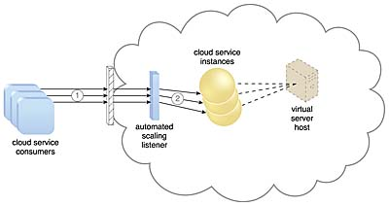

Figure 2: Cloud service consumers are sending requests to a cloud service (1). The automated scaling listener monitors the cloud service to determine if predefined capacity thresholds are being exceeded (2).

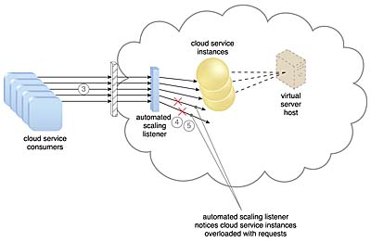

Figure 3: The number of requests coming from cloud service consumers increases (3). The workload exceeds the performance thresholds. The automated scaling listener determines the next course of action based on a predefined scaling policy (4). If the cloud service implementation is deemed eligible for additional scaling, the automated scaling listener initiates the scaling process (5).

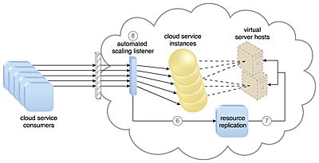

Figure 4: The automated scaling listener sends a signal to the resource replication mechanism (6), which creates more instances of the cloud service (7). Now that the increased workload has been accommodated, the automated scaling listener resumes monitoring and detracting and adding IT resources, as required (8).

The dynamic scalability architecture can be applied to a range of IT resources, including virtual servers and cloud storage devices. Besides the core automated scaling listener and resource replication mechanisms, the following mechanisms can also be used in this form of cloud architecture:

Cloud Usage Monitor – Specialized cloud usage monitors can track runtime usage in response to dynamic fluctuations caused by this architecture.

Hypervisor – The hypervisor is invoked by a dynamic scalability system to create or remove virtual server instances, or to be scaled itself.

Pay-Per-Use Monitor – The pay-per-use monitor is engaged to collect usage cost information in response to the scaling of IT resources.

2. explanation for chosen architecture

For clear analyzing, this architecture will collect the customers information that is saved in stores database and it can also include customers information that is signed from their desktop devices. The main system will check capacity of server if it can be suitable to put in system. When this system collect more cloud used, main server will process new procedure base on policy that predefined. When condition to access meet the requirement of spreading the space for cloud service. This is the point that bring advantage from this architecture because the data will be saved into single small store so there would be a moment that main server can be overload. If company want to put more data into there server they must check procedure based on there policy if the data from small store suitable for extending space. The main server will send the signal to copy the resources from other computer. This will make version of cloud service to store fully all data requested to be stored. This system has been extended which can increase the workload for process more request in future. With the explanation how it can work on scenario, this system can continuous expansion the system to handle all input data. System will prevent the overload problem to guarantee there always enough space to store user information but it can also put more resources at the same time to satisfy user request workload

P3 Define an appropriate deployment model for a given scenario.

1. type of development models in cloud computing

1.1 public cloud

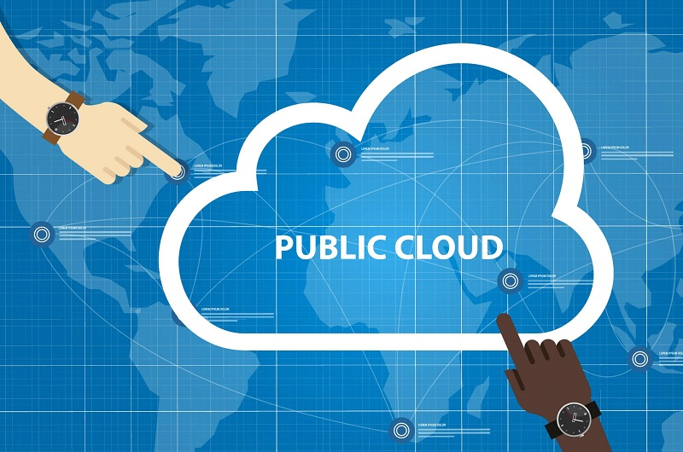

Figure 5: public cloud

The name speaks for itself: the public cloud is available to the public, and the data is generated and stored on third-party servers. The server infrastructure in terms of service providers manages it and manages the pool's resources, that's why user companies don't need to buy and maintain their own hardware. Resource companies provide free or pay-per-use information over the Internet. User has can open the resource on request. The public cloud deployment model is the first choice for businesses with low consulting rights concerns. When it comes to popular public cloud deployment models, Amazon Elastic Compute Cloud can be mentioned (Amazon EC2 - the leading service provider according to ZDNet).

1.2 private cloud

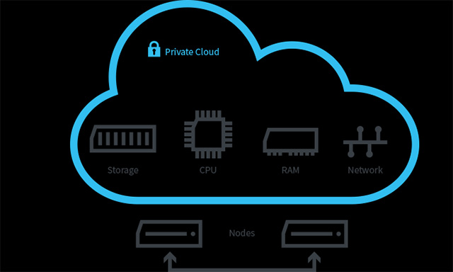

Figure 6: private cloud

There is little or no difference between the public model and the private model from a technical point of view, as their architectures are very similar. However, in contrast to public clouds that are available to users, private clouds are only one specific company that owns its own cloud. That is why it is also known as the internal model or the corporate model. Servers can be hosted offsite or on the owner's premises. Regardless of their physical location, these infrastructures are maintained on a designated private network and use software and hardware used only by the owner company. A clearly defined range of people have access to information held in a private repository, which prevents the public from using it. Due to numerous breaches in recent years, more and more large corporations have decided to use the private clouds model, as this minimizes data security issues.

1.3 Community Cloud

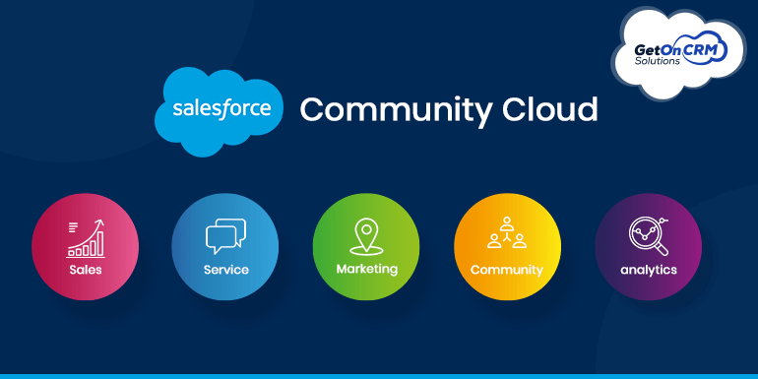

Figure 7: community cloud

The Community Cloud deployment model is largely the same as the Private Cloud model; the only difference is the set of users. While only one company owns its own cloud server, several organizations with similar backgrounds share the infrastructure and associated resources of the community cloud. If all participating organizations have identical security, privacy, and performance requirements, this multi-tenant data center architecture will help these companies improve their efficiency. them, as in the case of joint projects. A centralized cloud facilitates project development, management, and execution. The costs are shared by all users.

1.4 Hybrid Cloud

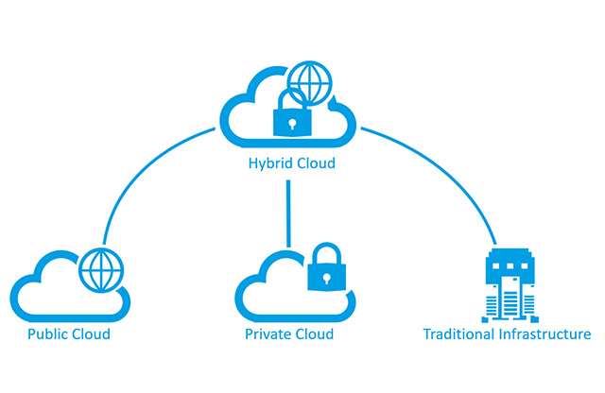

Figure 8: hybrid cloud

As is common with any combination, hybrid cloud includes the best features of the aforementioned deployment models (public, private, and community). It allows companies to mix and match aspects of the three categories that best suit their requirements.

For example, a company can balance its workload by locating mission-critical workloads in a secure private cloud and deploying less-critical workloads to the public cloud. The hybrid cloud deployment model not only protects and controls strategically important assets, but also in a cost and resource efficient manner. In addition, this approach facilitates data and application portability.

2 explanation for chosen models

Our best choice for scenario is private model. First reason to choose it because the controllable potential. When we are using private model, we will work in closed environment so we can easily to collect, store it into company database based on classification that is only known by employees in company. We do this to make sure can separate customers based on service packages that they had bought so we can give support that suitable for their pay. This also help to receive all internal information fast without get leak to the outside.

Second reason is about the cost. We know that if we go for public , we will need to put more the infrastructure and hardware computer to every where to accommodate all the number of users and the information chat flow is passed through. But with private model, we can use available infrastructures because it will be very difficult for outsiders to penetrate the infrastructure that has been fortified for a long time. What needs to be invested is computer hardware to create a powerful server to hold a large amount of internal and user information and above all to be able to repair it quickly and save time.

Third reason is high security. Working in closed environment so no outsiders know what happened in company. Most of information will just run around data path that has only set for data flow around main infrastructure. Private model also require some security step that create based on company policy such as declaring their roles and identities to have access to the amount of information that is only relevant to their position. This make Internal credentials become secret and fake credentials are easier to detect. This also applies to users, so when they want to make transactions, they also need to declare the information that the company requires before performing authorized activities.

Fourth reason is the simple customization. If company need to fix or upgrade, they can do it easily without any corruption among the system. This is better make a whole system for public because if just only one problem happened, all servers in public we get into error and we have to fix all of them which is so waste of time and resources. Private models can prevent the system form domino effect because all computer in company and small stores can work independently but still can control without any interrupt form outsiders. Free customization can also help to upgrade the hardware from time to time which make sure the security become stronger with new technology. This is will lead to superior performance in the future. New technology help a lot in creating firewall with Multiple layers of protection and keeping network connection between computers more stable.

P4 Compare the service models for choosing an adequate model for a given scenario.

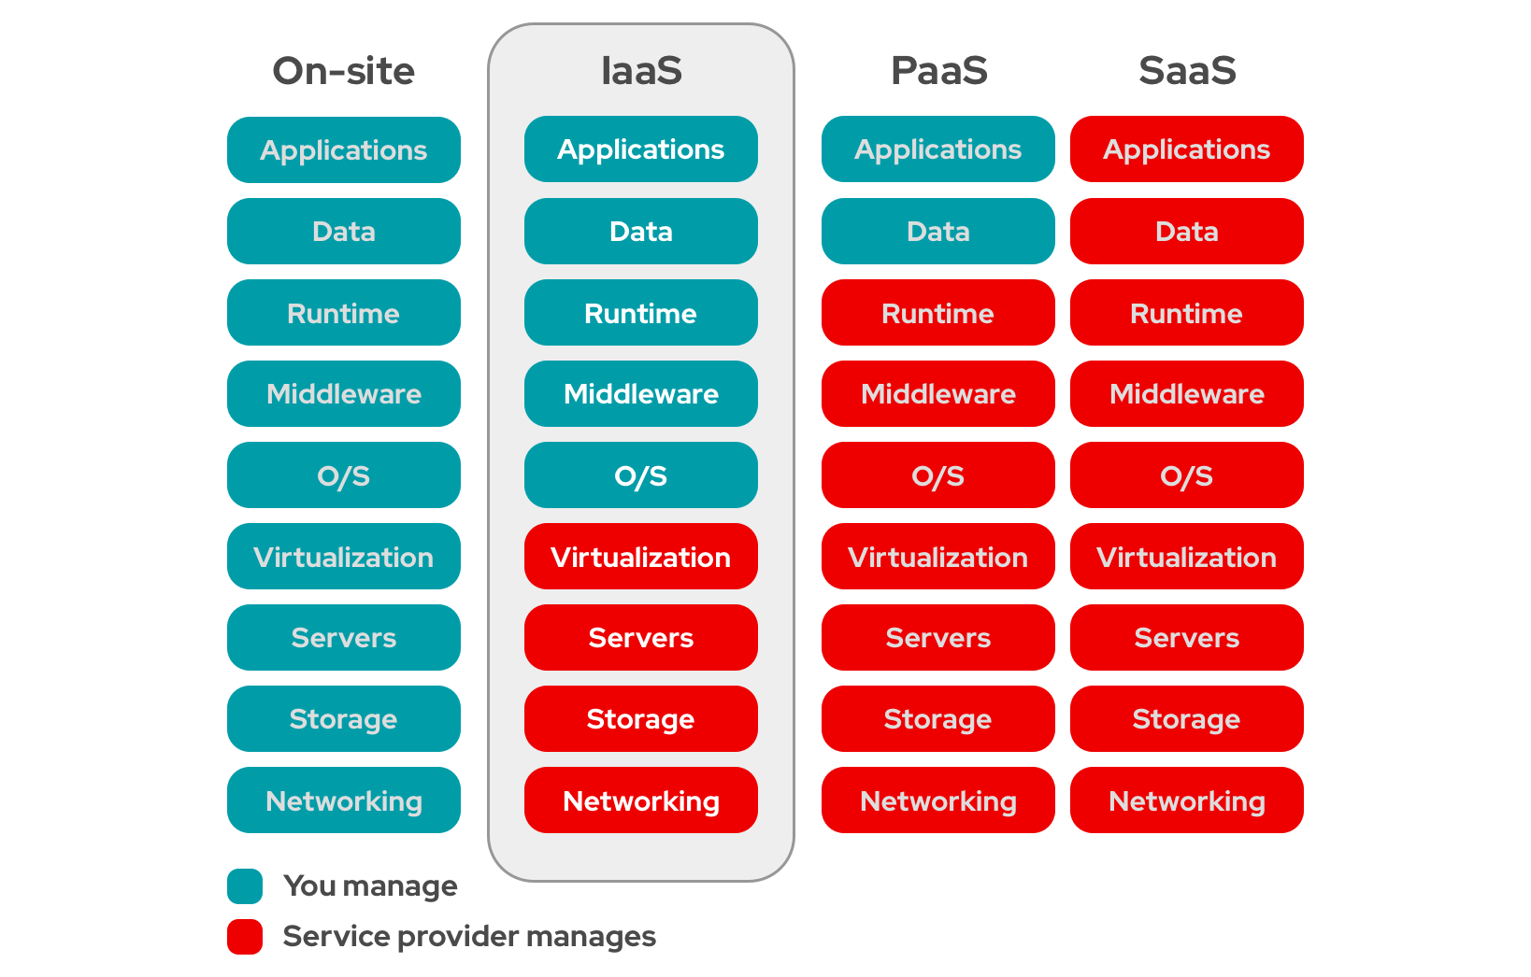

Figure 9: service models comparision

1. all models

* IaaS - Infrastructure as a Service: it is the bottom layer of the foundation of the cloud computing pyramid. IaaS is the most comprehensive and flexible type of Cloud Computing service available. It essentially provides a fully virtualized computing infrastructure that is provisioned and managed over the internet. The IaaS provider will take the role of managing the physical infrastructure such as servers, data storage space, ... in the data center. They allow users to fully customize those virtualized resources to their specific needs. With IaaS, customers can purchase, install, configure, and manage any software they need to use. With high scalability and flexibility, companies only pay for the portion of virtual resources they use. This solves the problem of users' initial investment in building the system. They do not need to spend too much money, while still being able to use the "terrible" infrastructure as they like. Microsoft Azure, Amazon Web Services (AWS),... are typical examples for this type of Cloud Computing service.
* PaaS - Platform as a Service: The second tier on the Cloud Computing pyramid is PaaS. If IaaS provides all the tools available through the cloud and gives full rights to customers to use, PaaS is a bit more specialized. PaaS provides the necessary “kits” to build, test, deploy, manage, and update software products. It just uses the same infrastructure as IaaS. But it also provides other tools such as operating system, middleware, etc. needed to create software applications. In a nutshell, with PaaS, what businesses receive is not only infrastructure but also tools for developing their products. Some examples of Cloud Computing in the form of PaaS such as AWS Elastic Beanstalk, Apache Stratos, Google App Engine, Microsoft Azure,...
* SaaS - Software as a Service: This service sits at the top of the Cloud Computing pyramid. Most people will know and hear more about this form of Cloud Computing. By simply it is an almost complete software solution. It is packaged to be made available to users directly over the Internet by simply registering to use it. With this form of Cloud Computing, it almost completely optimizes the requirements for the end user. Even some SaaS applications are deployed via web browsers, businesses do not need to struggle with common installation operations. Now, the SaaS provider does it all. From managing the infrastructure, operating systems, middleware and data needed to deliver the program, ensuring that the software is available wherever and whenever customers need it. These Cloud Computing applications as SaaS allow businesses to get up and running very quickly. At the same time, the expansion of the scale of operations is equally fast. Microsoft Office 365, Salesforce, Cisco WebEx, Google Apps,... are typical examples of this form of Cloud Computing in the form of SaaS.

Models compare

|  |  |  |
| --- | --- | --- |
| models | Advantage | disadvantage |
| Paas | * PaaS-built software is highly scalable, available and multi-tenant, as it is cloud-based * The development process is quickened and simplified * Reduced expenses for creating, testing and launching apps * Automated company policy * Reduced amount of coding required * Allows for easy migrating to the hybrid cloud | * Data security issues * Compatibility of existing infrastructure (not every element can be cloud-enabled) * Dependency on vendor’s speed, reliability and support |
| Saas | * No hardware costs * No initial setup costs * Automated upgrades * Cross-device compatibility * Accessible from any location * Pay-as-you-go model * Scalability * Easy customization | * Loss of control * Limited range of solutions * Connectivity is a must |
| Iaas | * The most flexible and dynamic model * Cost-effective due to pay-as-you-go pricing * Easy to use due to the automated deployment of hardware * Management tasks are virtualized, so employees have more free time for other tasks | * Data security issues due to multitenant architecture * Vendor outages make customers unable to access their data for a while * The need for team training to learn how to manage new infrastructure |

2. explanation for chosen model

Basing on scenario, the model we will choose is Paas. Basically, ATN is a service company and their main products are toys so they will need to build a software that allow them to collect all customers information and send to cloud to finish their orders. Coding with Paas models can make a simple and efficiency software for customers which also help employees feel more easy to control users data. Paas brings many different tools for developers to create their software in many different ways which help to find a right way to approach users and it easy to stack mutil cloud-base in just one database. This can also interact automatically with company policy. As we mention before if this model combine with private cloud this can help to prevent the danger access from the outsiders and we can easy to control.

Paas have specail technique to exchange order cloud serviec to hyprid cloud. This is made flexible system for transport data to the form we want. This will not interrupt to system we built and it also allow us to buils a new one and combine with the old one but still working separately.

References

1. ranger, s., 2022. What is cloud computing? Everything you need to know about the cloud explained. [online] ZDNet. Available at: <https://www.zdnet.com/article/what-is-cloud-computing-everything-you-need-to-know-about-the-cloud/> [Accessed 12 June 2022].
2. Uchie, 2022. History & Evolution of Cloud Computing: What to Expect in 2025. [online] Seasia Infotech Blog. Available at: <https://www.seasiainfotech.com/blog/history-and-evolution-cloud-computing/> [Accessed 12 June 2022].
3. VMware. 2022. What is a Public Cloud? | VMware Glossary. [online] Available at: <https://www.vmware.com/topics/glossary/content/public-cloud.html> [Accessed 12 June 2022].
4. neenan, 2022. What Is Public Cloud? Everything You Need to Know. [online] SearchCloudComputing. Available at: <https://www.techtarget.com/searchcloudcomputing/definition/public-cloud> [Accessed 12 June 2022].
5. Viettelidc.com.vn. 2020. Public Cloud là gì? Mọi thứ bạn cần biết về Public Cloud. [online] Available at: <https://viettelidc.com.vn/tin-tuc/public-cloud-la-gi-moi-thu-ban-can-biet-ve-public-cloud> [Accessed 12 June 2022].
6. Netapp.com. 2022. What is Hybrid Cloud? Definition and Benefits | NetApp. [online] Available at: <https://www.netapp.com/hybrid-cloud/what-is-hybrid-cloud/#:~:text=Hybrid%20cloud%20refers%20to%20a,orchestration%20among%20the%20various%20platforms.> [Accessed 12 June 2022].
7. Hoàng, P., 2022. Giải ngố về các khái niệm IaaS, PaaS, SaaS trong Cloud Computing. [online] Từ coder đến developer - Tôi đi code dạo. Available at: <https://toidicodedao.com/2018/10/23/so-sanh-iaas-paas-saas-la-gi/> [Accessed 12 June 2022].
8. watts, s., 2020. What Is XaaS? Everything as a Service Explained. [online] BMC Blogs. Available at: <https://www.bmc.com/blogs/xaas-everything-as-a-service/> [Accessed 12 June 2022].
9. Rosencrance, 2021. SaaS vs. IaaS vs. PaaS: Differences, Pros, Cons and Examples. [online] WhatIs.com. Available at: <https://www.techtarget.com/whatis/SaaS-IaaS-PaaS-Comparing-Cloud-Service-Models> [Accessed 12 June 2022].
10. Fingent Technology. 2021. Cloud Service Models Saas, IaaS, Paas - Choose the Right One for Your Business - Fingent Technology. [online] Available at: <https://www.fingent.com/blog/cloud-service-models-saas-iaas-paas-choose-the-right-one-for-your-business/> [Accessed 12 June 2022].